Restaurant Configuration

Path : Operation >> Settings >> Restaurant Configuration.
Steps to reach Restaurant Configuration:
Step 1 : Operation in Steps to reach Restaurant Configuration : Open the Operation module from the main Billing Application (POS).
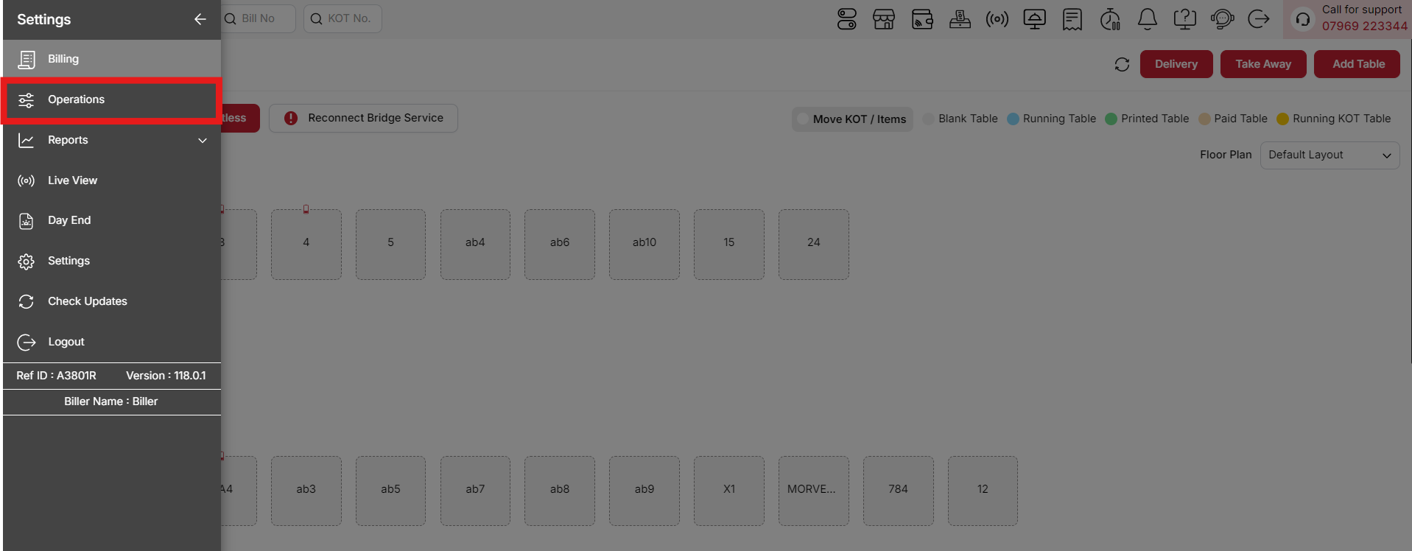
{Image Name: Operations,
Description: The red box highlights the Operations menu in the sidebar, offering tools like Reconnect Bridge Service and order management options. Users can handle tasks such as fixing connectivity and managing tables like Blank Table and Running Table. Here is an image of Step 1 Operations in Steps to Reach Restaurant Configuration.}
Step 2 : Settings in Steps to reach Restaurant Configuration : Click on Settings.
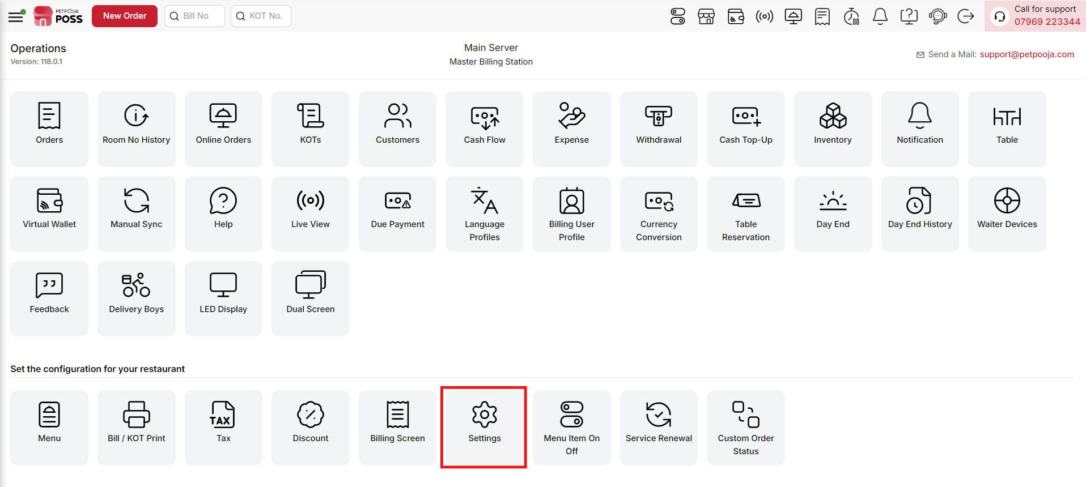
{Image Name: Settings,
Description: The Settings option allows you to configure and customize restaurant operations as per requirements. It helps manage system preferences, billing options, and overall POS setup for smooth functionality.Here is an image of Step 2 Settings in Steps to Reach Restaurant Configuration.}
Step 3 : Restaurant Configuration in Steps to reach Restaurant Configuration : Select Restaurant Configuration to manage outlet-specific settings such as table setup, service types, working hours, and other operational preferences.
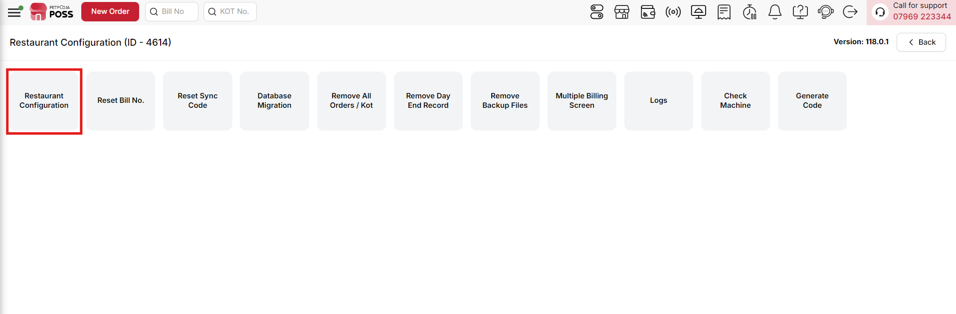
{Image Name: Restaurant Configuration,
Description: The Restaurant Configuration option allows you to set up and customize system settings. It helps manage restaurant preferences, billing, and operational configurations for smooth functioning.Here is an image of Step 3 Restaurant Configuration in Steps to Reach Restaurant Configuration.}

Key Features Of Restaurant Configuration :
(Restaurant Configuration) Note: If you are not able to see or use the Restaurant Configuration option in your billing application, it means that you do not have the required permission. To enable this, you need to go to the Owner Dashboard and open the User Management section. Inside User Management, you will find a permission called Point of Sale Configuration Details. You must checkmark this option to give access. After allowing the permission, perform a manual sync so the system updates the rights properly. Once the sync is done, log out from the billing application and then log in again. After this process, the Restaurant Configuration option will become visible and you can use it without any problem.

(Restaurant Configuration) Restaurant Closing Hours :

(Restaurant Closing Hours) How to Change Closing Hours in Billing App :
- Go to Operation in the billing application.
- Then go to Settings.
- Select Restaurant Configuration.
- The first option is Restaurant Closing Hours.
(Restaurant Closing Hours) You will see two options:
1. Change Closing Hour (Restaurant Closing Hours) :
- Click this option.
- Enter your restaurant’s new closing hour.
- Click Confirm to save it.
- This will set the new closing time for your restaurant.
2. Extend Closing Hour (Restaurant Closing Hours) :
- If your restaurant normally closes at, for example, 12:00 midnight, you can extend it temporarily.
- This option adjusts your running tables and ongoing orders according to the extended time.
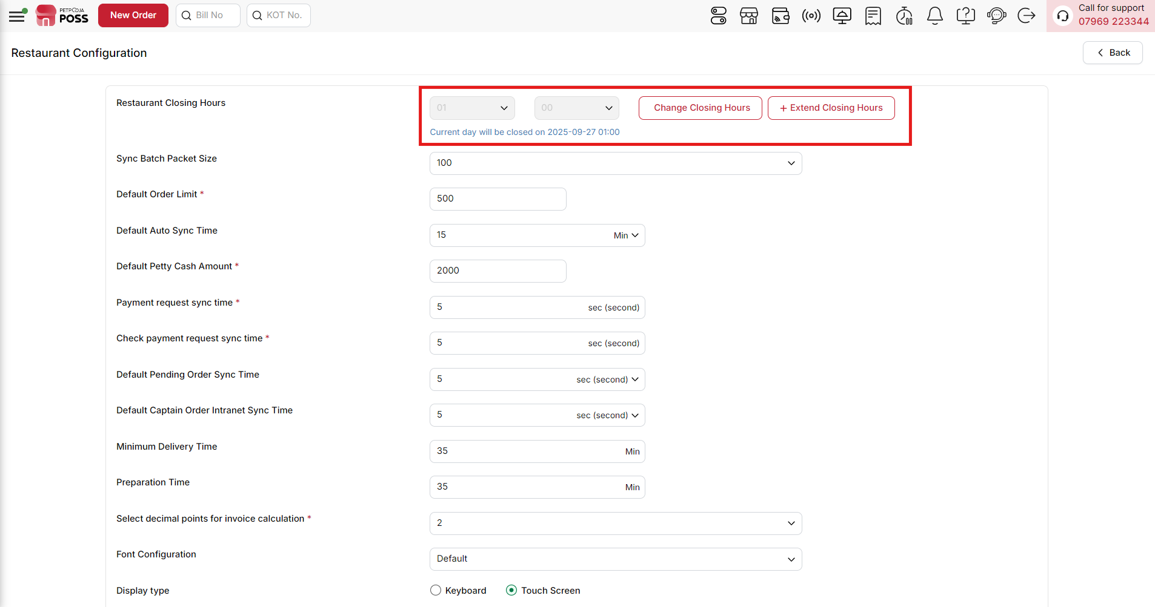
{Image Name: Closing Hours Options,
Description: The highlighted section allows users to set or extend the restaurant’s closing hours. It provides flexibility to adjust operational timings and manage order availability accordingly.}
(Restaurant Configuration) Sync Batch Packet Size : This setting is for POS. It controls how many orders will sync at one time from POS to the server. If you set this number to 100, then 100 orders will go together in one packet when syncing.This helps to send the data in small parts so the system works smoothly and does not get slow. You can change this number based on how many orders your outlet has and how fast your internet is.
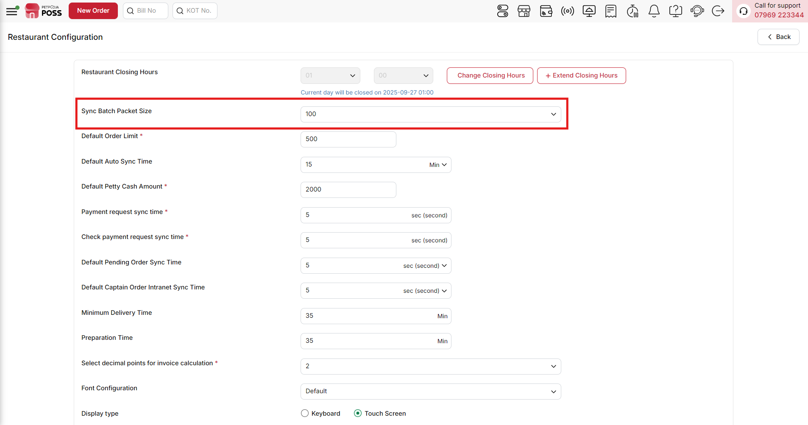
{Image Name: Sync Batch Packet Size,
Description: The highlighted field is used to define the number of records processed in each synchronization batch. It helps optimize system performance and ensures smooth data transfer during syncing operations.}

(Restaurant Configuration) Default Order Limit : This setting is for POS. It decides how many orders will be shown on the POS screen. If you set it to 200, only the latest 200 orders will be shown — older orders will not be visible.This helps the POS system work faster and smoother, especially in busy outlets. By showing only a limited number of orders, it reduces load and makes the order screen easier to use.
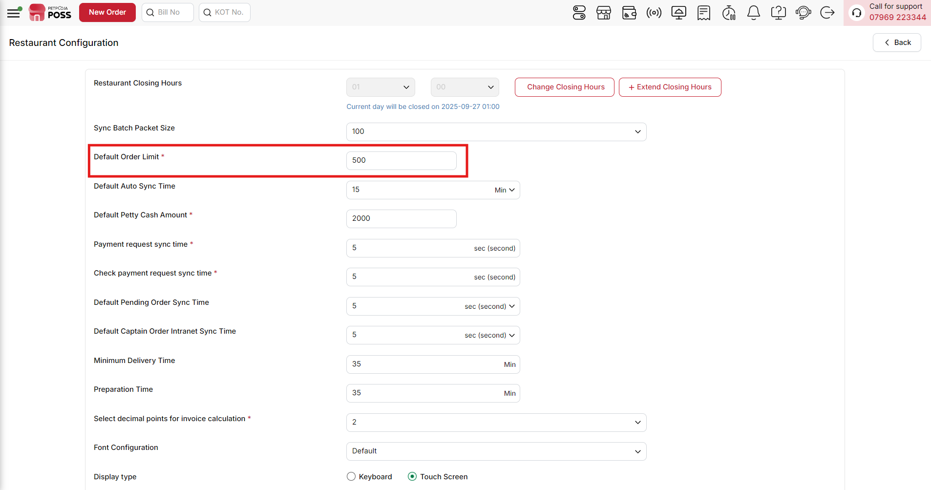
{Image Name: Default Order Limit,
Description: The highlighted field sets the maximum number of orders that can be handled by default. It helps control workload and ensures the system functions efficiently within the defined capacity.}
(Restaurant Configuration) Default Auto Sync Time (Order And Order Sync Settings)(Billing System Settings) : This setting is for POS. It controls how often the orders will automatically sync from POS to the dashboard. For example, if it's set to 5 minutes, the orders will sync every 5 minutes without needing to press anything.This helps keep the data updated on the dashboard regularly. Please note, the internet must be connected for auto-sync to work. It’s useful to make sure all order data goes to the server on time without any delay.
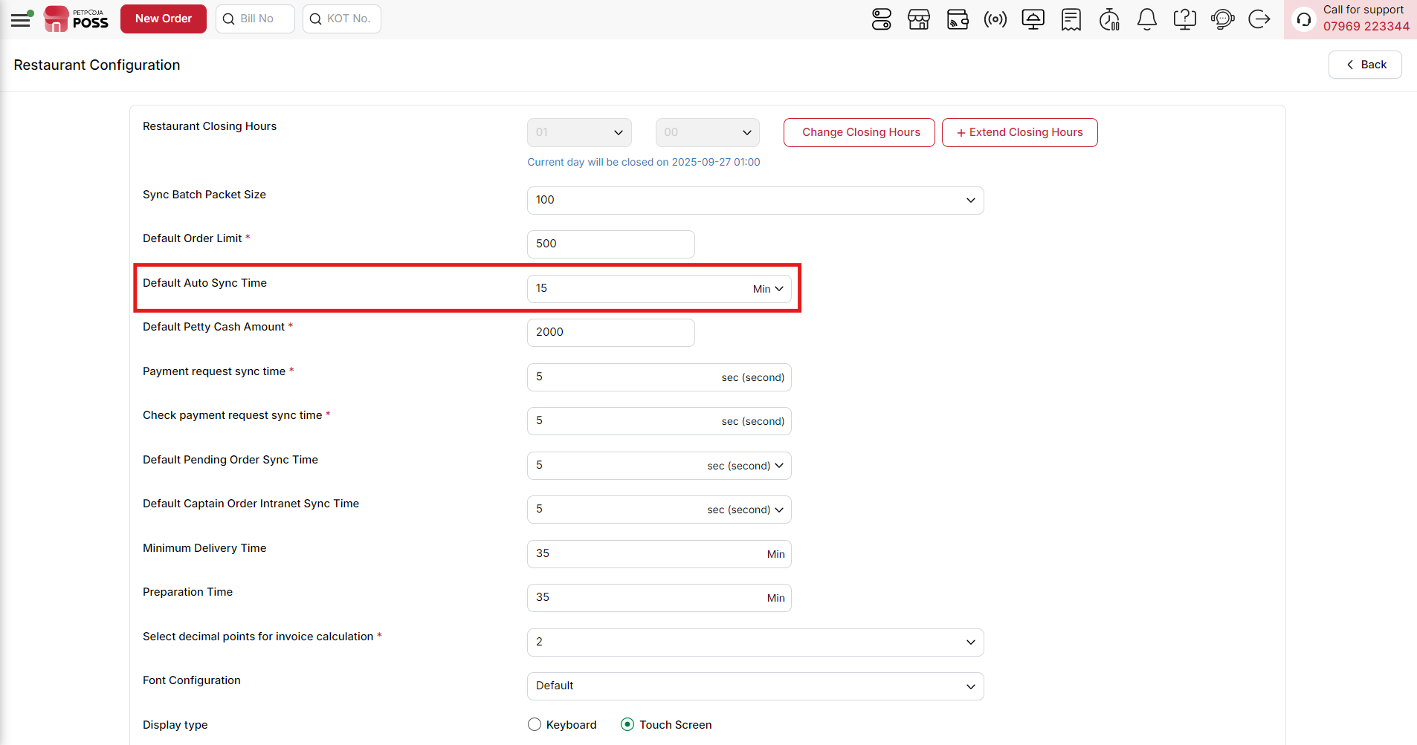
{Image Name: Default Auto Sync Time,
Description: The highlighted field specifies the default time interval for automatic data synchronization. It ensures that updates are regularly synced without requiring manual intervention.}

(Restaurant Configuration) Default Petty Cash Amount (Mandatory Field) :
This setting lets you set a fixed petty cash amount that will automatically appear when you open a new cash counter. Petty cash is the initial cash kept in the register for giving change or handling small expenses during the day.
How it works:
- When you open a cash counter, the petty cash field will automatically show the amount you set here (for example, ₹500 or ₹1000).
- You can still change this amount manually if needed while opening the counter.
- This feature saves time and avoids mistakes, especially in outlets where the same petty cash amount is used every day.
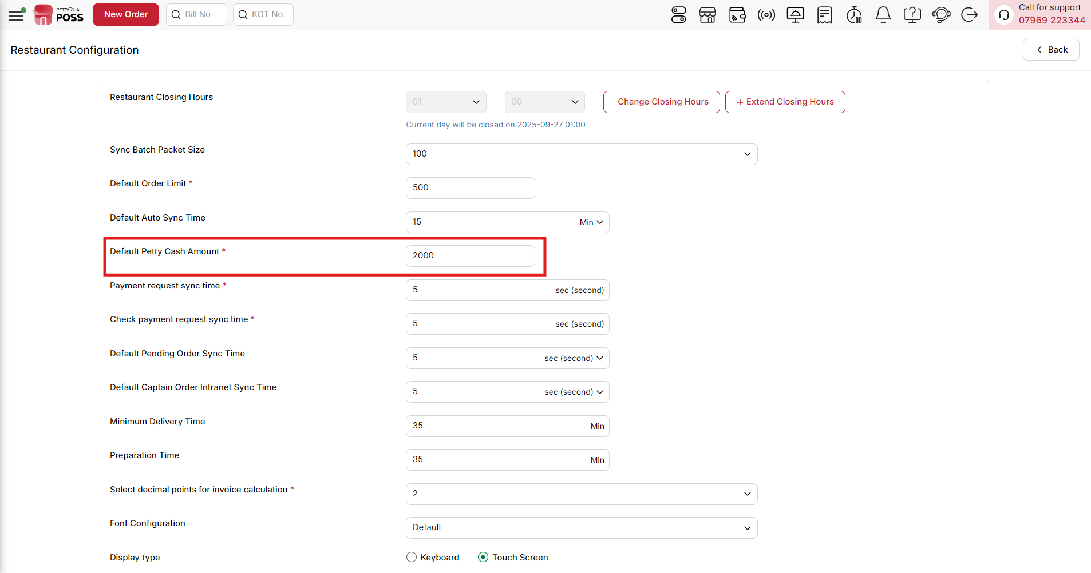
{Image Name: Default Petty Cash Amount,
Description: The highlighted field defines the default petty cash balance maintained in the system. It ensures quick handling of small expenses and smooth daily financial operations.}

(Restaurant Configuration) Payment request sync time : This setting lets you decide how often the billing system should check for new payment requests. You can enter the time in minutes in the provided field. The system will follow this interval to sync payment requests automatically, ensuring that the latest updates are reflected in the billing application. You can adjust this time as needed, and the system will continue to fetch payment requests at the set interval, helping the billing process stay smooth and up to date.
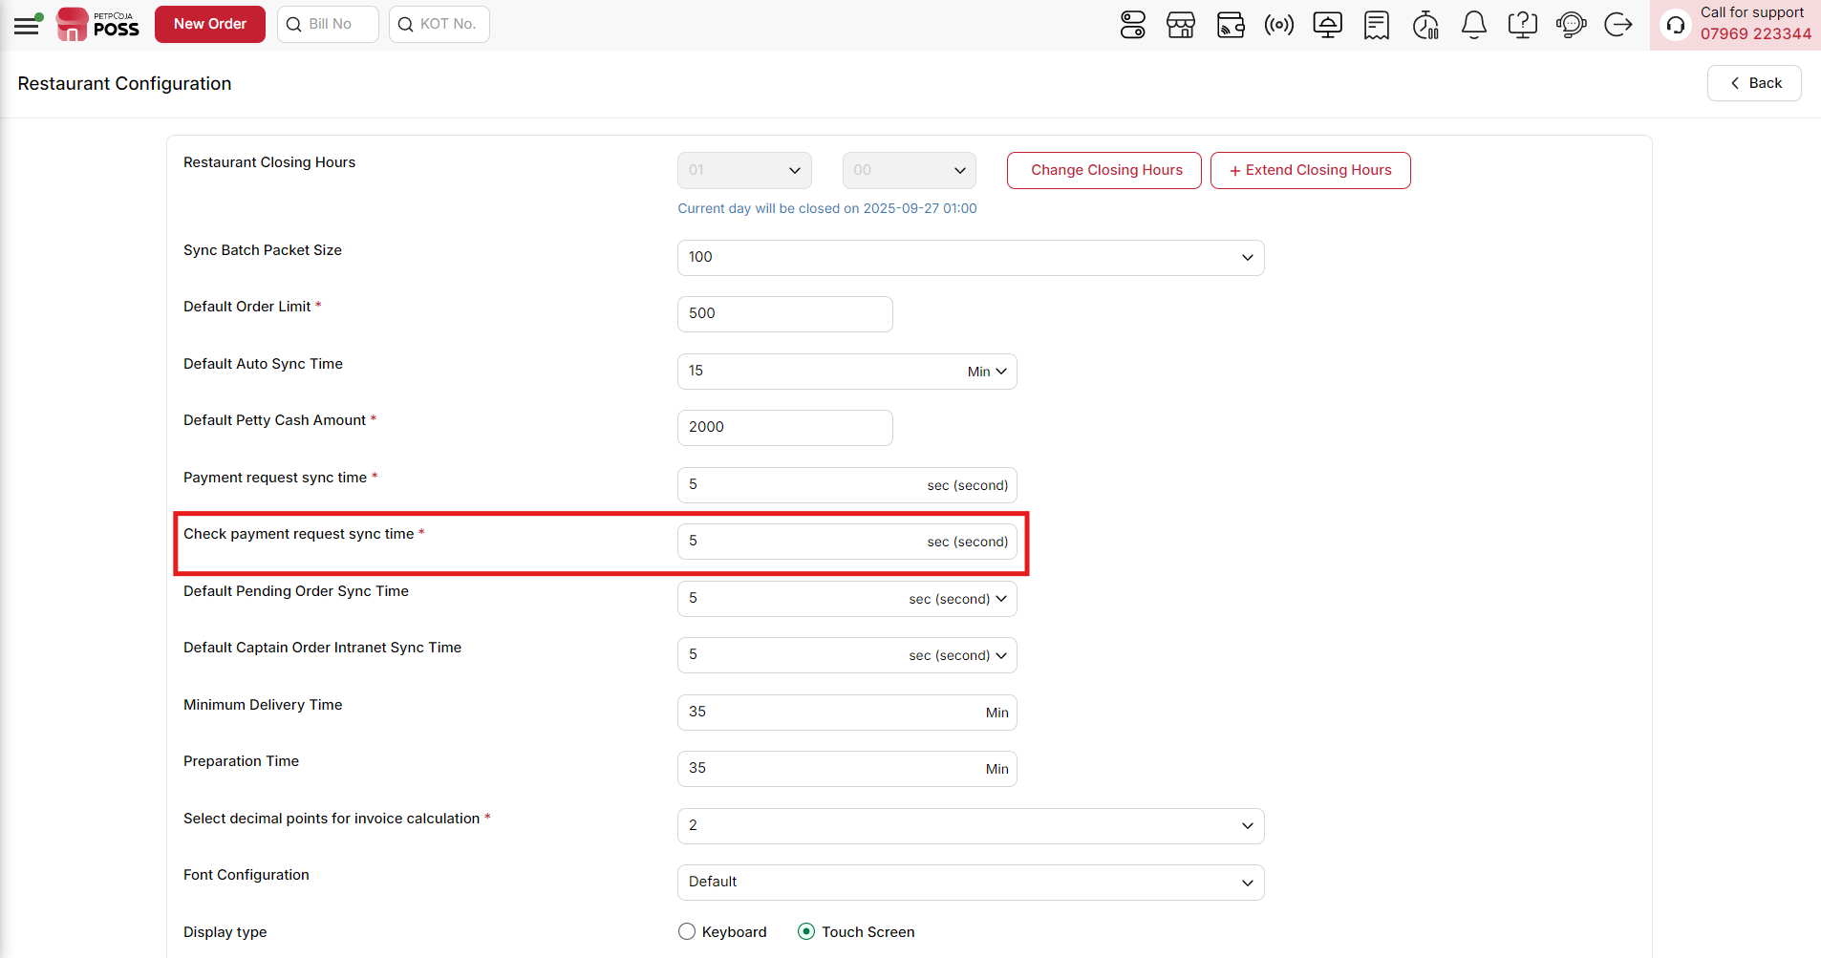
{Image Name: Payment Request Sync Time,
Description: The highlighted field sets the interval at which payment requests are synchronized. It ensures that payment updates are processed promptly for accurate transaction handling.}

(Restaurant Configuration) Check Payment Request Sync Time (Mandatory Field) : This setting allows you to set how often the billing system should check for existing payment requests. You can enter the time in minutes in the text field, and the system will follow this interval to review and update any pending or ongoing payment requests. Adjusting this time helps ensure that all payment information stays current, and the billing process remains smooth and synchronized.

{Image Name: Check Payment Request Sync Time,
Description:The highlighted field defines how often the system checks for payment request updates. It helps maintain accurate tracking of payment confirmations in real time.}
(Restaurant Configuration) Default Pending Order Sync Time : This setting is for POS. It controls how often pending orders (orders not yet synced) will be sent to the dashboard. For example, if it’s set to 10 minutes, the POS will try to sync all pending orders every 10 minutes.This is helpful when some orders didn’t sync due to internet issues. Once the internet is back, the system will automatically try to sync them based on this time. Please note, the internet must be connected for auto-sync to work.
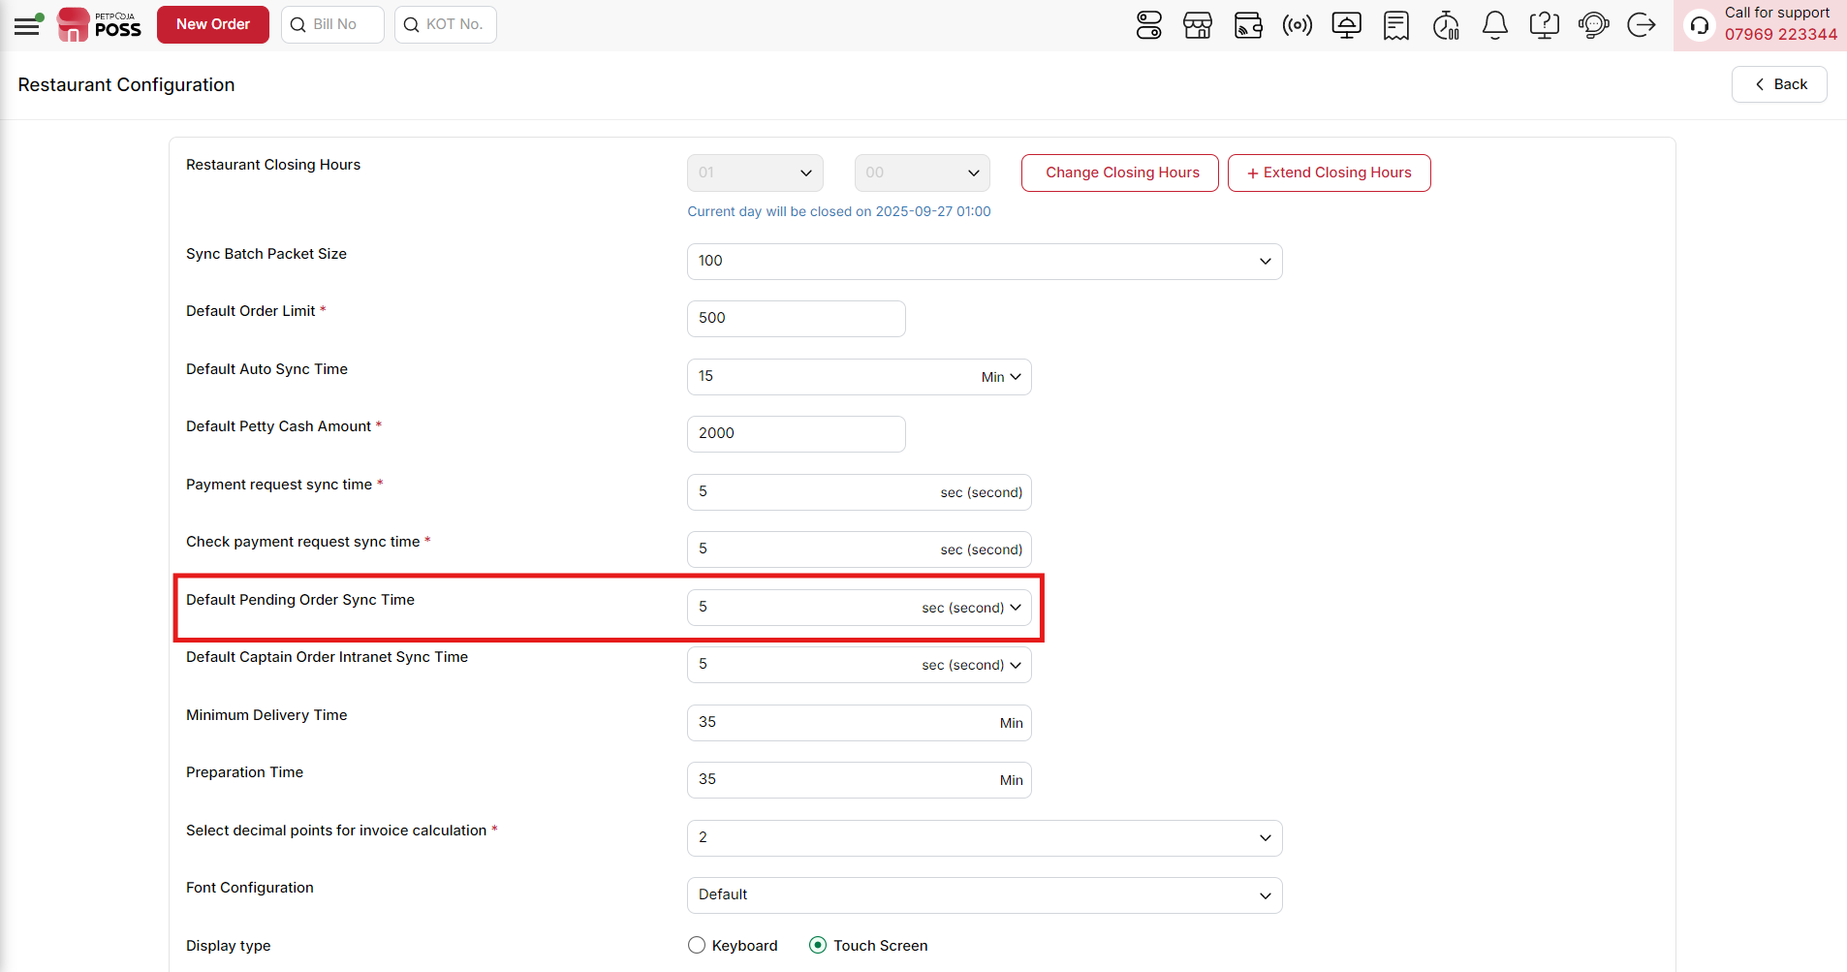
{Image Name: Default Pending Order Sync Time,
Description: The highlighted field sets the interval for synchronizing pending orders. It ensures that unprocessed orders are regularly checked and updated in the system.}

(Restaurant Configuration) Default Captain Order Intranet Sync Time : This setting is for POS. It controls how often captain orders will sync to the POS system using the local network (intranet). For example, if you set it to 5 seconds, the captain orders will sync every 5 seconds.This helps captain orders reach the POS quickly so there is no delay in service. The time you set here will decide how fast the sync happens.

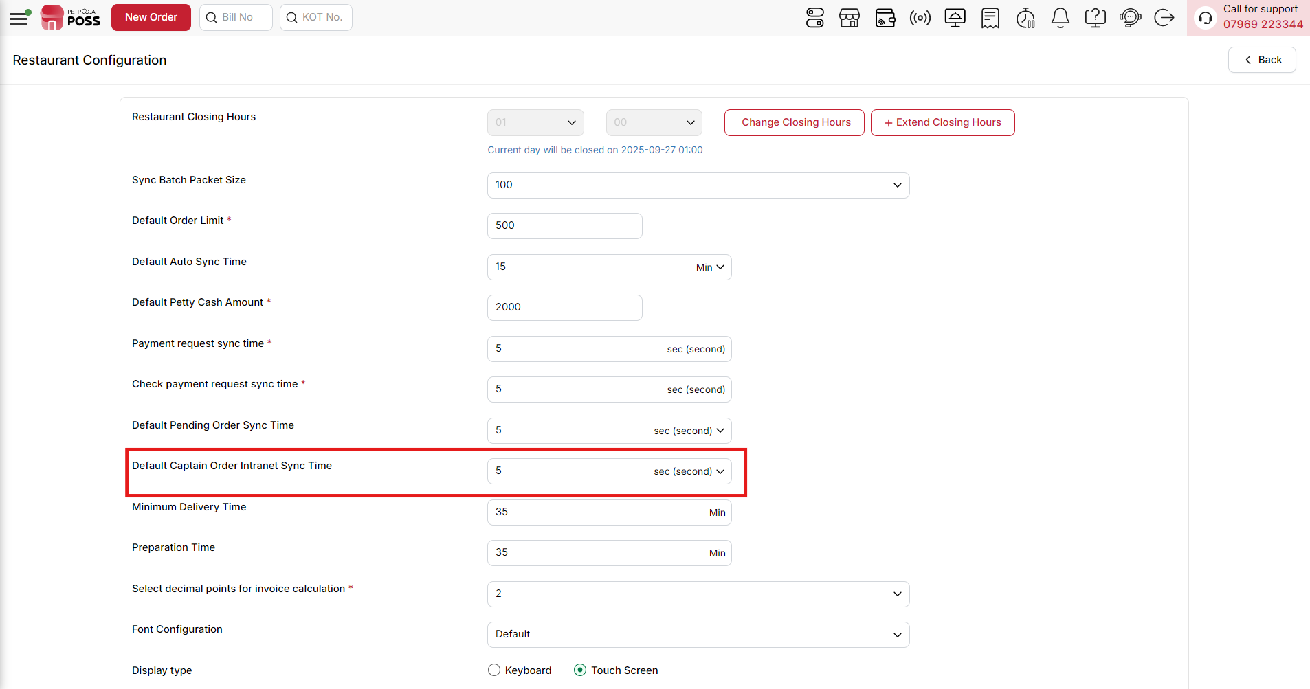

{Image Name: Default Captain Order Intranet Sync Time,

Description: The highlighted field sets how frequently captain (waitstaff) orders are synchronized over the intranet. This ensures that orders taken by captains are updated in the system at regular intervals for smooth order processing.}

(Restaurant Configuration) Minimum Delivery Time : This option defines the minimum time required to deliver an order after it's prepared. It helps online platforms estimate and display realistic delivery times to customers, ensuring smoother operations and accurate delivery expectations.
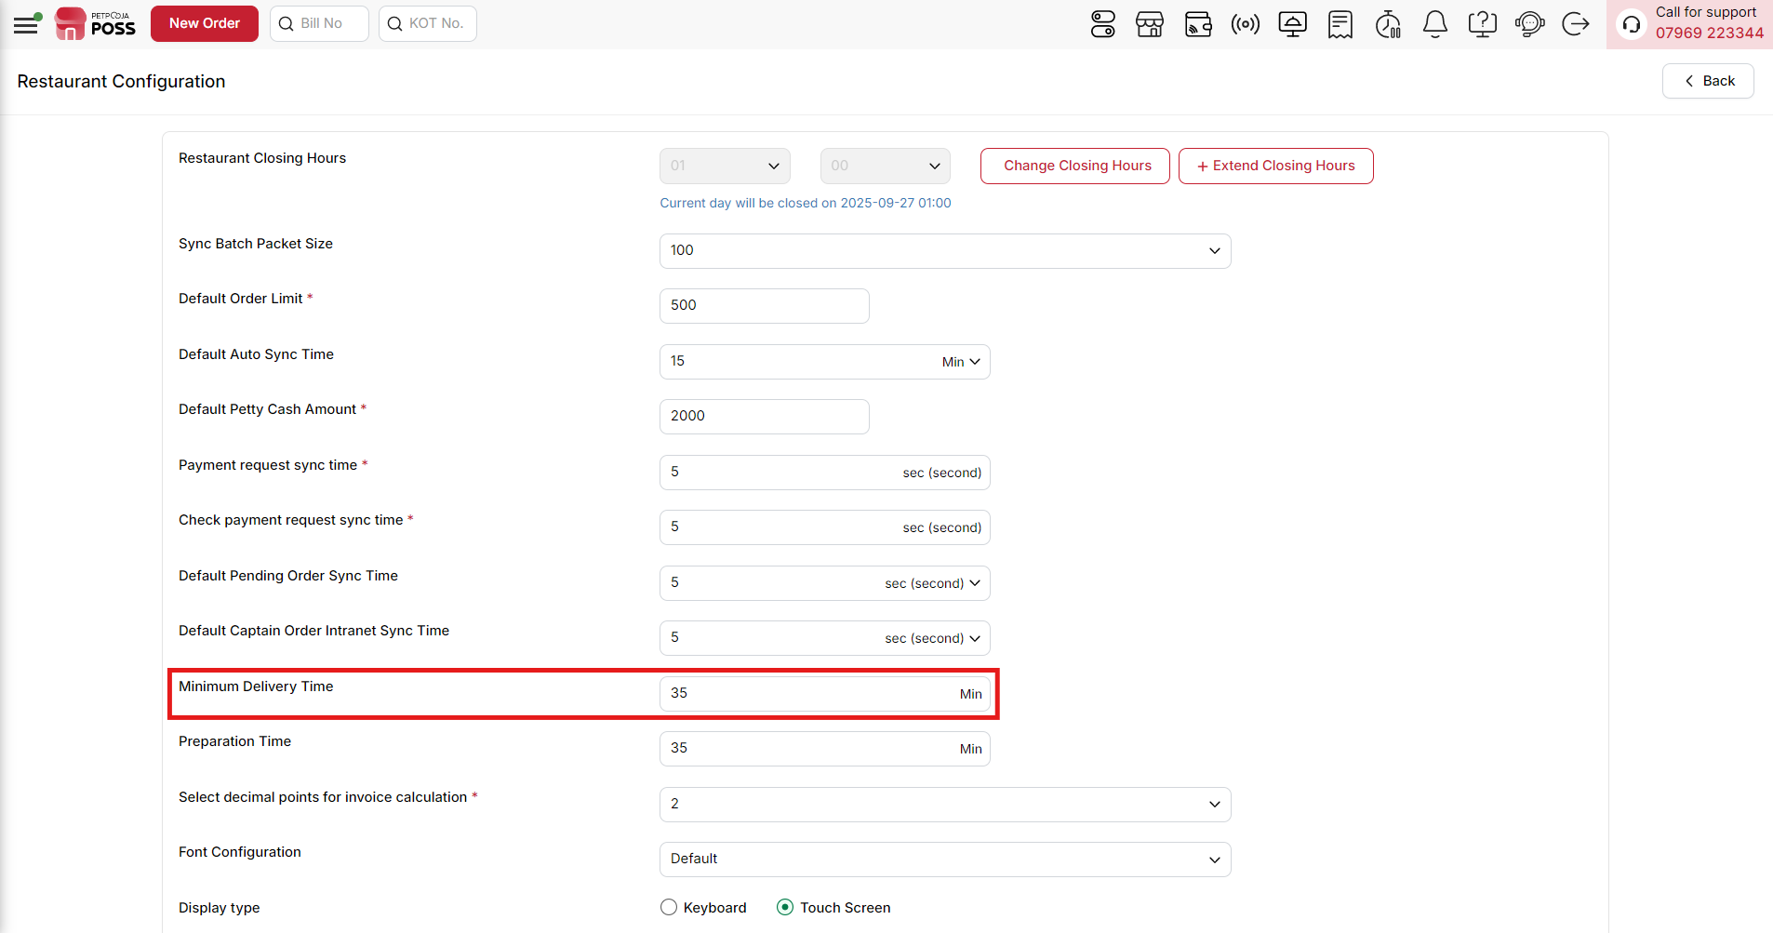

{Image Name: Minimum Delivery Time,

Description: The highlighted field defines the minimum time (in minutes) required for delivering an order.}

(Restaurant Configuration) Preparation Time (Minimum Preparation Time) : This option sets the shortest time required to prepare an order before it's ready for pickup or delivery. It helps online platforms display accurate delivery or pickup times, ensuring customers have the right expectations for when their order will be ready.
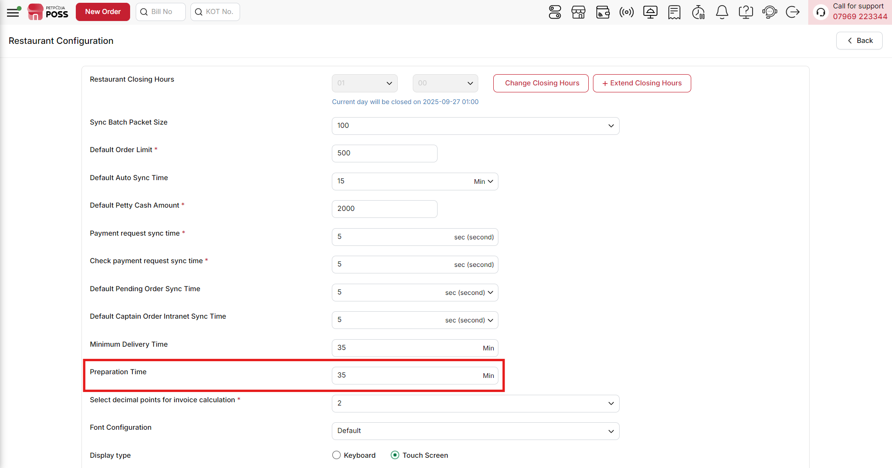
{Image Name: Preparation Time,
Description: The highlighted field specifies the preparation time (in minutes) required to get an order ready before delivery or pickup. This helps the system calculate accurate delivery and order completion estimates.}

(Restaurant Configuration) Select Decimal Points for Invoice Calculation (Mandatory Field) : This setting allows you to control how many decimal points are shown in invoices and menu prices. You can choose the level of precision, so numbers are rounded accordingly. For example, if you select "1," a value like 0.9277 will be rounded and displayed as 1.0. This helps keep invoices and menu prices clear, easy to read, and consistent across the outlet.
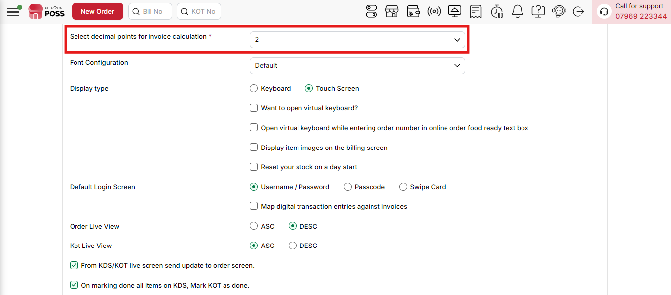
{Image Name: Select decimal points for invoice calculation,
Description: The highlighted field allows you to configure how many decimal points should be used in invoice calculations.}

(Restaurant Configuration) Font Configuration: Go to the font settings in your billing application to configure invoice and receipt printing.
Choose Font Option : You will see two options:
- Default – Prints invoices and receipts in the standard font size.
- Small – Prints invoices and receipts in a smaller font size for a compact layout.
Save Changes : After selecting the option, click Save to apply the changes.
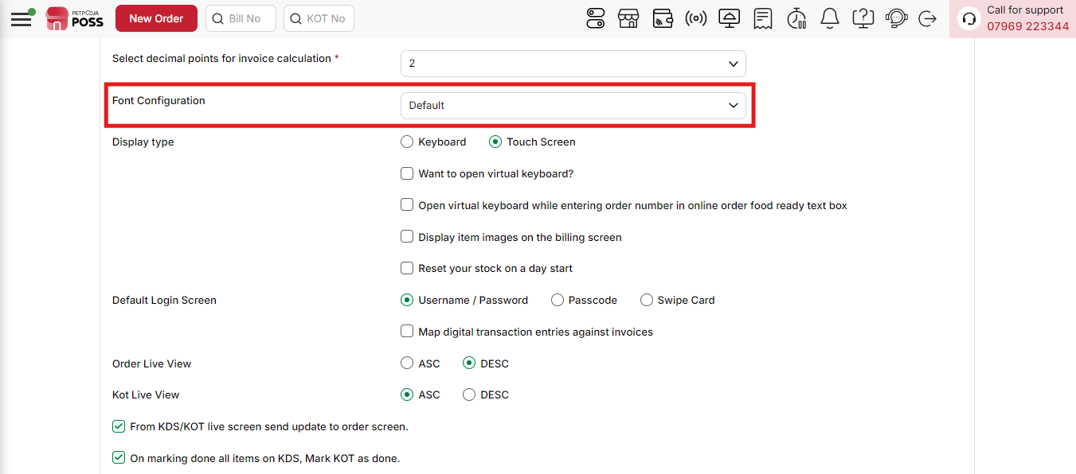
{Image Name: Font Configuration,
Description: The highlighted field allows you to set the font style used in the POS system interface. Choosing a different font configuration can improve readability and match the restaurant’s branding style. Currently, it is set to Default.}

(Restaurant Configuration) Display Type :
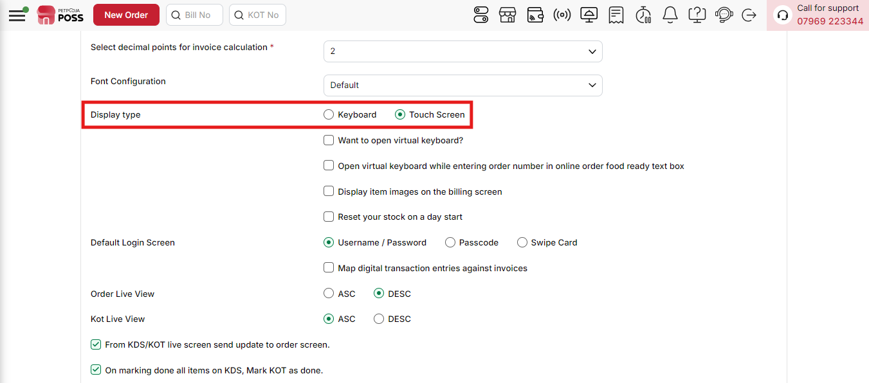
{Image Name: Display type,
Description: The red box highlights the option to select the input/display type for operating the POS system. Users can choose between Keyboard or Touch Screen modes, depending on their device preference. Currently, the Touch Screen option is selected.}

(Display Type) Keyboard Mode : In this mode, the system is designed for working with a keyboard. It is useful in places where staff mainly type or use shortcut keys to enter data quickly. This makes billing and other tasks faster without depending on a mouse.
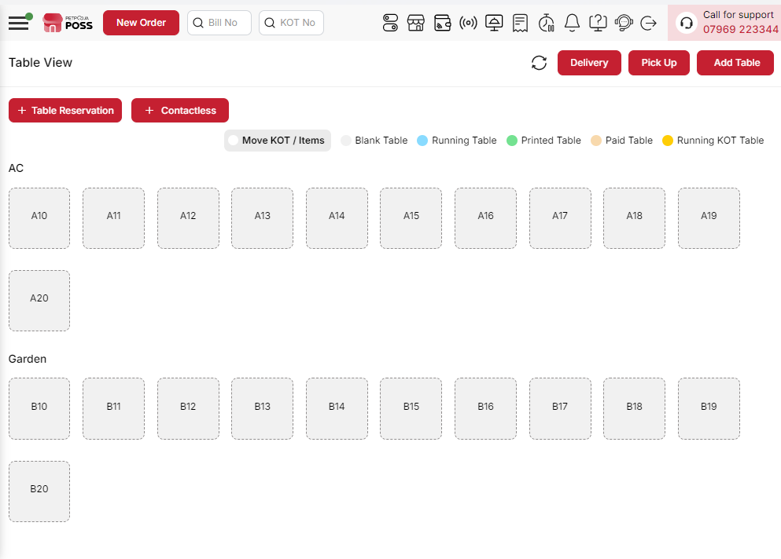
{Image Name: Touch View (Billing Application),
Description: This is the Touch View of the billing application, displaying tables in AC and Garden sections. Tables are color-coded by status for easy management, optimized for touchscreen use.}

(Display Type) Touch Screen Mode : In this mode, the system is designed for touch input. The buttons become larger, the spacing improves, and you can use actions like tap or swipe. This makes it simple and smooth to handle billing without needing a keyboard or mouse.
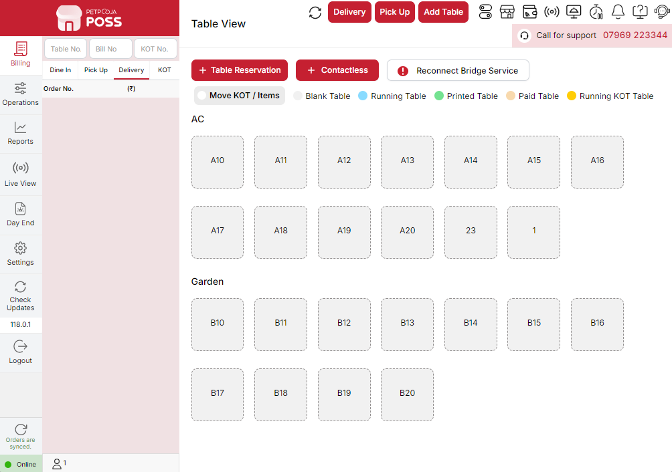
{Image Name: Keyboard View (Billing Application),
Description: This is the Keyboard View of the billing application, showing AC and Garden section tables. It is designed for desktop use with keyboard navigation for managing orders efficiently.}
(Restaurant Configuration) Want to Open Virtual Keyboard ? :
- Check: If this box is checked, the system will open a virtual keyboard on the screen whenever typing is required. This is useful for touchscreen devices where a physical keyboard is not available.
- Uncheck: If this box is unchecked, the system will not show a virtual keyboard, and staff will need to use a physical keyboard for typing.
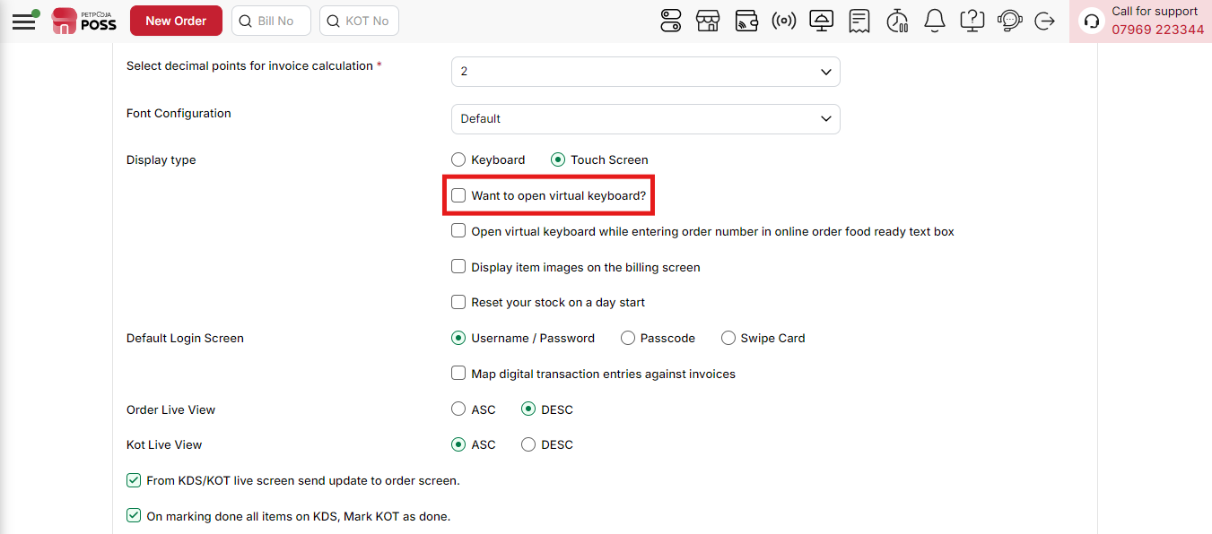
{Image Name: Virtual Keyboard Option,
Description: This setting allows enabling the virtual keyboard for ease of use, especially on touch-screen devices, making order entry more convenient without relying on a physical keyboard.}
(Restaurant Configuration) Open virtual keyboard while entering order number in online order food ready text box :
- Check: If this box is checked, a virtual keyboard will automatically open when entering the online order number in the Food Ready text box. This helps staff easily type order numbers on touchscreen devices.
- Uncheck: If this box is unchecked, the virtual keyboard will not appear, and the order number must be entered using a physical keyboard.
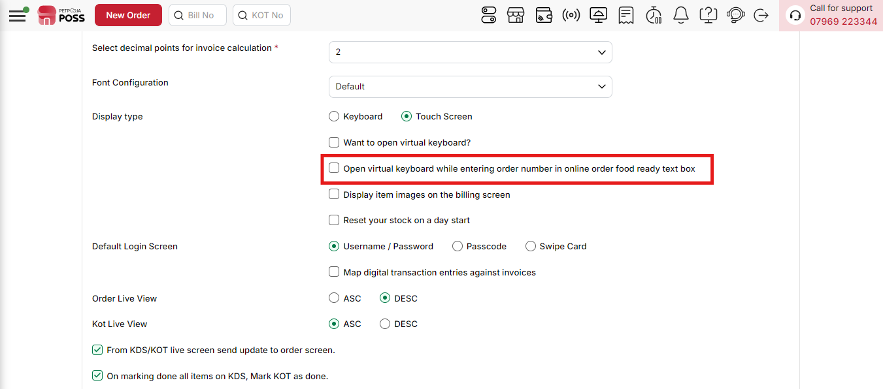
{Image Name: Virtual Keyboard for Online Orders,
Description: This option enables the virtual keyboard specifically when entering order numbers in the online order food-ready text box, improving ease of use on touch devices.}
(Restaurant Configuration) Display Item Images on the Billing Screen :
- Check: If this option is checked, the item images will be shown on the billing screen. This helps staff quickly identify products by looking at their pictures, reducing mistakes during order punching.
- Uncheck: If this option is unchecked, the billing screen will not display item images, and items will be listed only by their names.
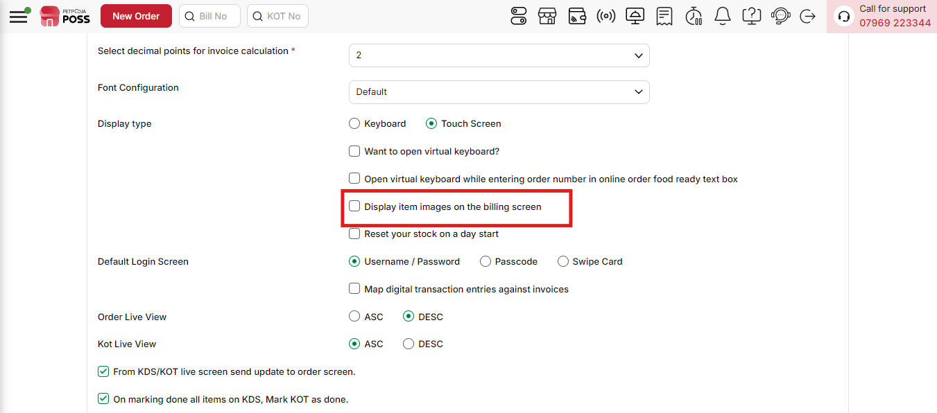
{Image Name: Display Item Images on Billing Screen,
Description: This option allows you to show product/item images on the billing screen, making it easier for staff to identify items visually during order processing.}
(Restaurant Configuration) Reset Your Stock on a Day Start :
- Check: If this option is checked, the system will automatically reset all stock quantities to default values at the beginning of each day. This helps start every day with a fresh stock count.
- Uncheck: If this option is unchecked, stock quantities will continue from the previous day without resetting.
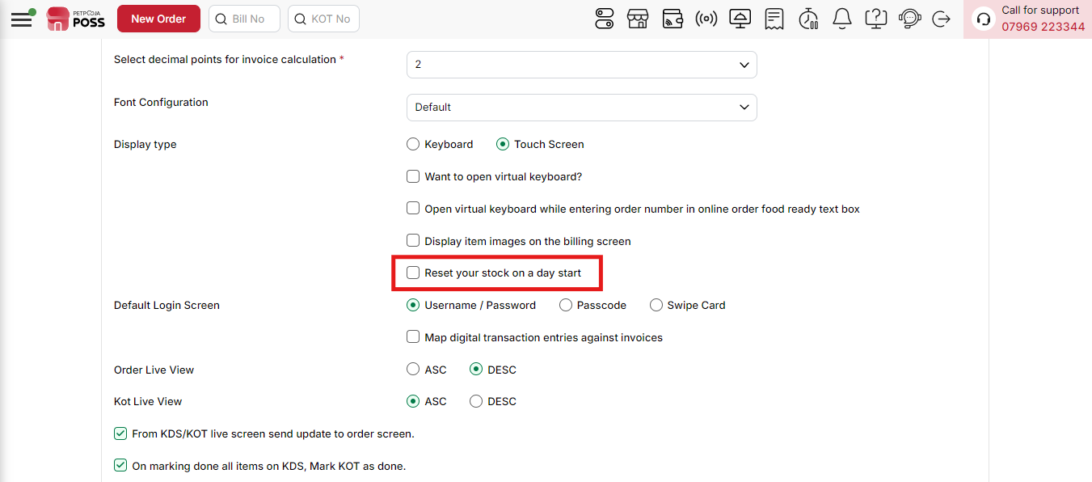
{Image Name: Reset Stock at Day Start,
Description: This option resets stock quantities automatically at the start of each day, ensuring inventory begins fresh for daily operations.}

(Restaurant Configuration) Default Login Screen : This option allows you to decide how users will log in to the billing application. You can choose one of the following methods
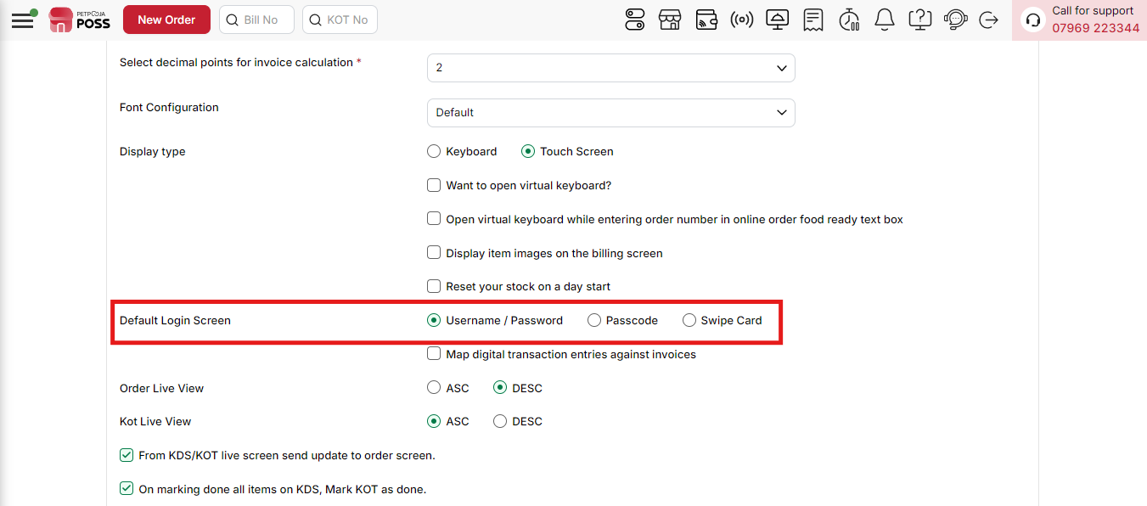
{Image Name: Default Login Screen,
Description: This setting allows you to choose the default login method for users Username/Password, Passcode, or Swipe Card for secure and flexible access.}
- (Default Login Screen) Username / Password – Enter your registered username and password. This is the standard login method.
  - To use this, create usernames and passwords for each user in the system.
  - During login, the user needs to type both fields correctly to access the billing application.
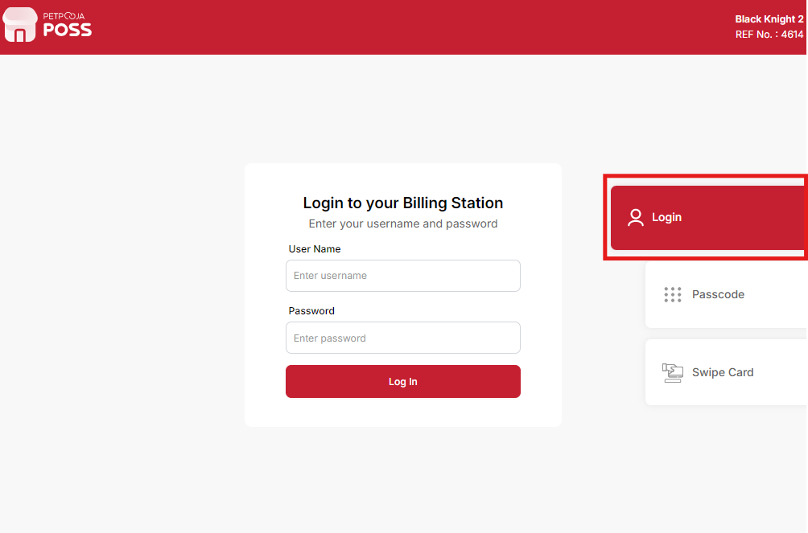
{Image Name: Login with Username & Password,
Description: This screen lets users securely log in using their username and password to access the billing station.}
- (Default Login Screen) Passcode – A quick way to log in using only a numeric passcode (like a PIN).
  - To use this, assign a passcode to each user from the user settings.
  - At login, the user simply types the passcode instead of full credentials.
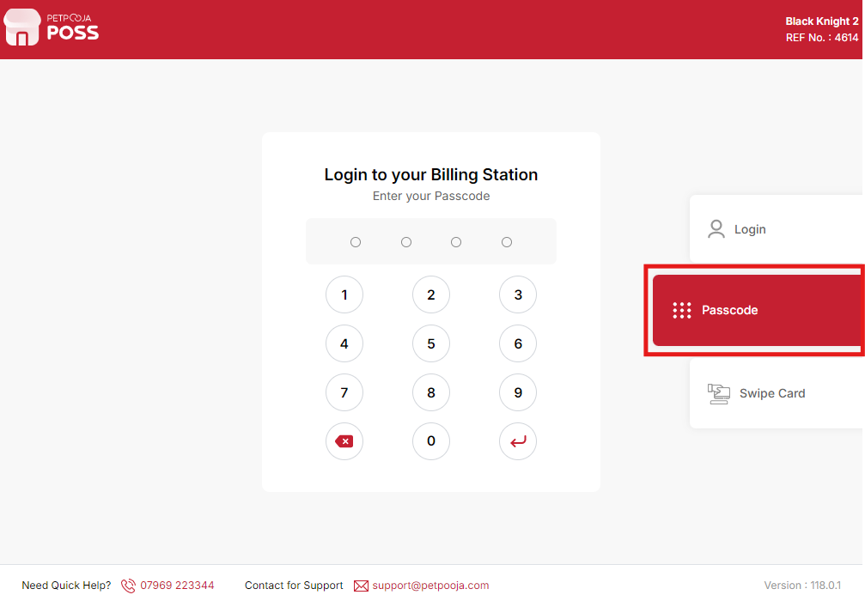
{Image Name: Login with Passcode,
Description: This screen enables users to log in quickly using a secure numeric passcode for billing station access.}
- (Default Login Screen) Swipe Card – Login using a magnetic swipe card linked to the user’s account.
  - To use this, set up a swipe card and register it in the system against a user profile.
  - The user just swipes the card at the POS terminal to log in instantly.
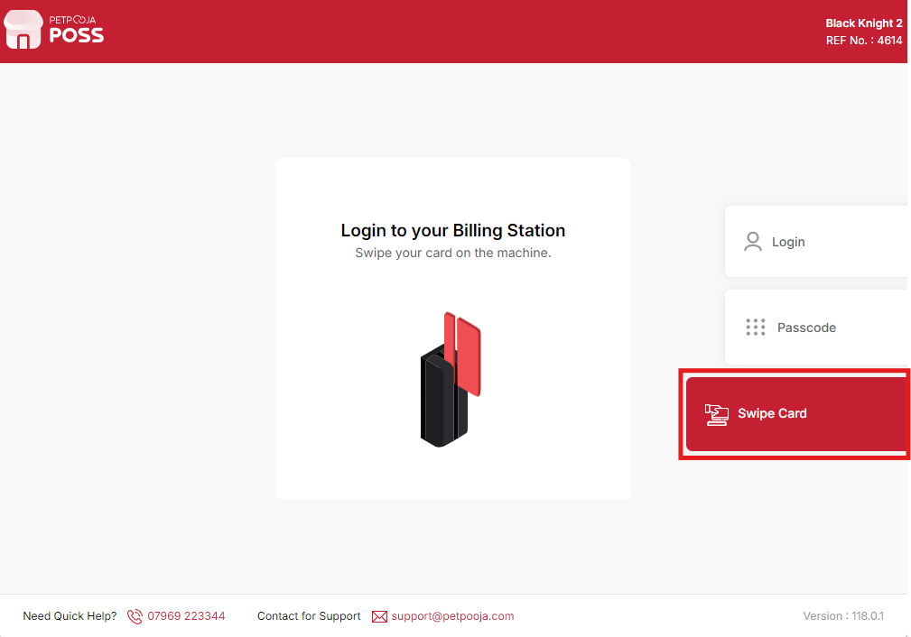
{Image Name: Login with Swipe Card,
Description: This screen allows users to log in by swiping their card on the connected billing machine for instant access.}
(Restaurant Configuration) Map digital transaction entries against invoices :
- Check: If this box is checked, the system will automatically link digital payment transactions (like card payments, UPI, wallets) to their respective invoices. This makes accounting and reconciliation easier.
- Uncheck: If this box is unchecked, digital transactions will not be automatically linked to invoices, and staff may need to manually match payments with invoices.
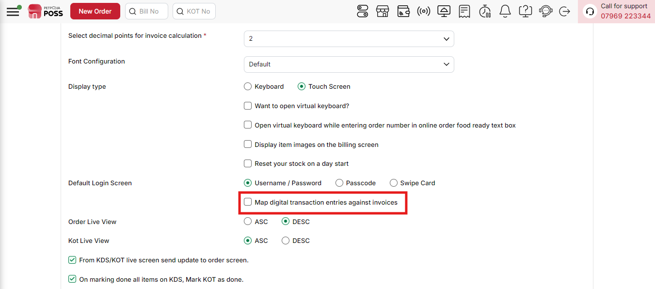
{Image Name: Map Digital Transactions,
Description: This option helps to map digital payment entries directly against invoices, ensuring accurate reconciliation of online transactions.}

(Restaurant Configuration) Order Live View :
This option allows you to decide how the orders will be shown on the live order screen. You can choose the order in which new and old orders appear.
- (Order Live View) ASC (Ascending Order) :
  - Orders will be shown from oldest to newest.
  - Example: If the first order came at 2:00 PM and the next at 2:05 PM, the 2:00 PM order will appear at the top.
- (Order Live View) DESC (Descending Order) :
  - Orders will be shown from newest to oldest.
  - Example: If the latest order came at 2:10 PM, it will appear at the top, and older orders will move down.
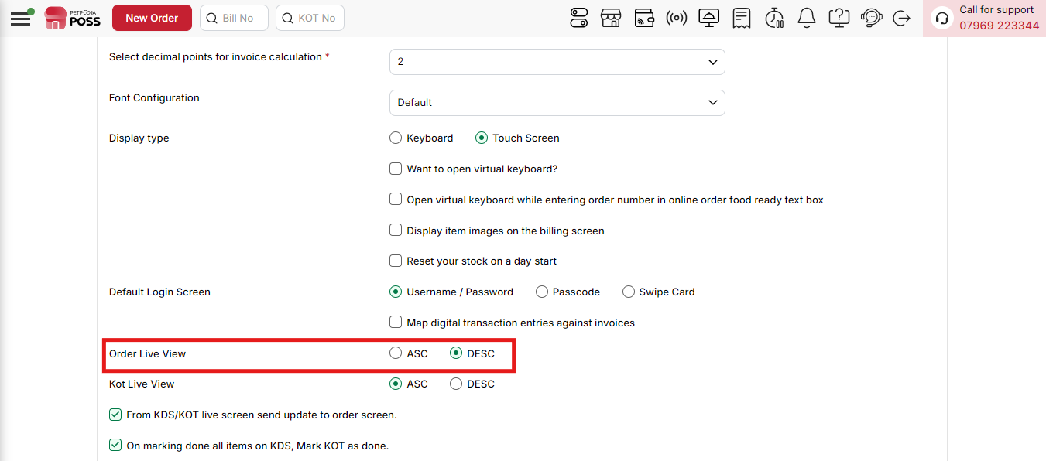
{Image Name: Order Live View,
Description: This setting defines how orders appear on the live screen, allowing you to view them in ascending (ASC) or descending (DESC) order for better tracking.}

(Restaurant Configuration) KOT Live View :
This option lets you choose how KOTs (Kitchen Order Tickets) are displayed on the live screen. You can decide whether older or newer KOTs appear first.
- (KOT Live View) ASC (Ascending Order):
  - KOTs are shown from oldest to newest.
  - Example: The first KOT created will appear at the top, and the newest will appear at the bottom.
- (KOT Live View) DESC (Descending Order):
  - KOTs are shown from newest to oldest.
  - Example: The latest KOT will appear at the top, and older KOTs will move down.
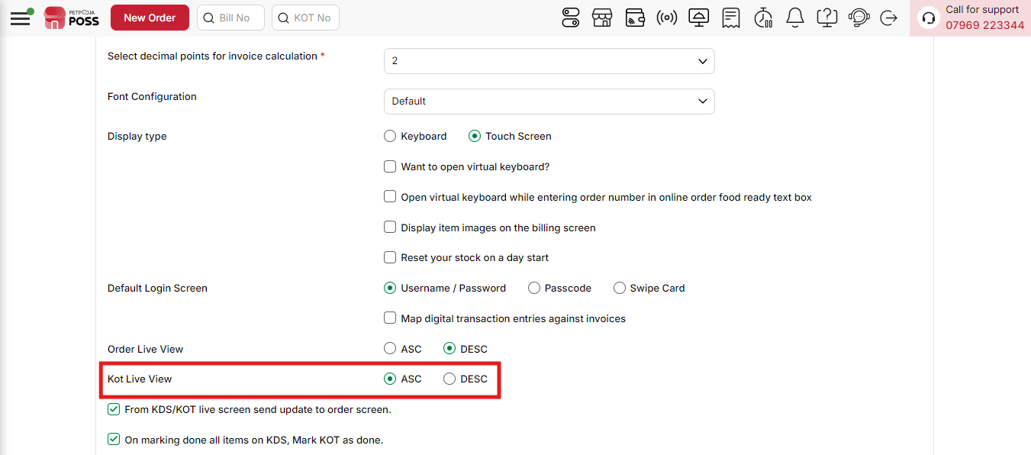
{Image Name: Kot Live View,
Description: The red box highlights the Kot Live View option, which allows users to manage the sequence of Kitchen Order Tickets. Users can choose to display the KOT list in ascending (ASC) or descending (DESC) order for better tracking and management.}
(Restaurant Configuration) From KDS/KOT Live Screen Send Update To Order Screen :
- Check: If this box is checked, any changes made in the KDS or KOT (like item updates, cancellations, or modifications) will be automatically updated on the order screen. This ensures that staff always see the latest order status in real-time.
- Uncheck: If this box is unchecked, changes in KDS/KOT will not reflect on the order screen automatically. Staff will see outdated information unless they refresh manually.
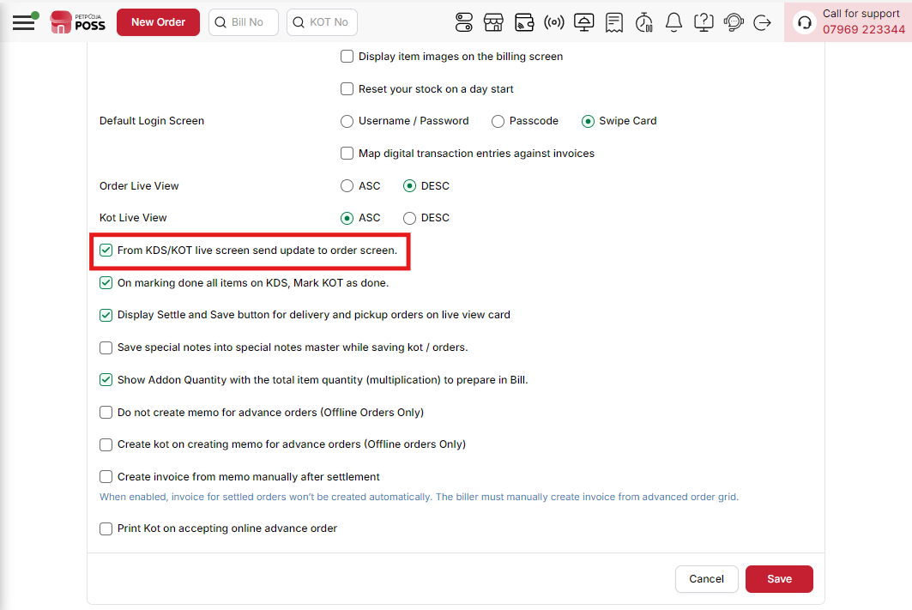
{Image Name: From KDS/KOT Live Screen Send Update to Order Screen,
Description: The red box highlights the option to enable automatic updates from the KDS/KOT live screen to the order screen.}
(Restaurant Configuration) On marking done all items on KDS, Mark KOT as done. : Automatically marks the KOT as done when all items are processed.
- Check: If this box is checked, the system will automatically mark the KOT as done once all items in that KOT are completed on the KDS. This helps staff know which orders are fully prepared without manual intervention.
- Uncheck: If this box is unchecked, the KOT will not be marked as done automatically, and staff must manually update the KOT status when all items are completed.
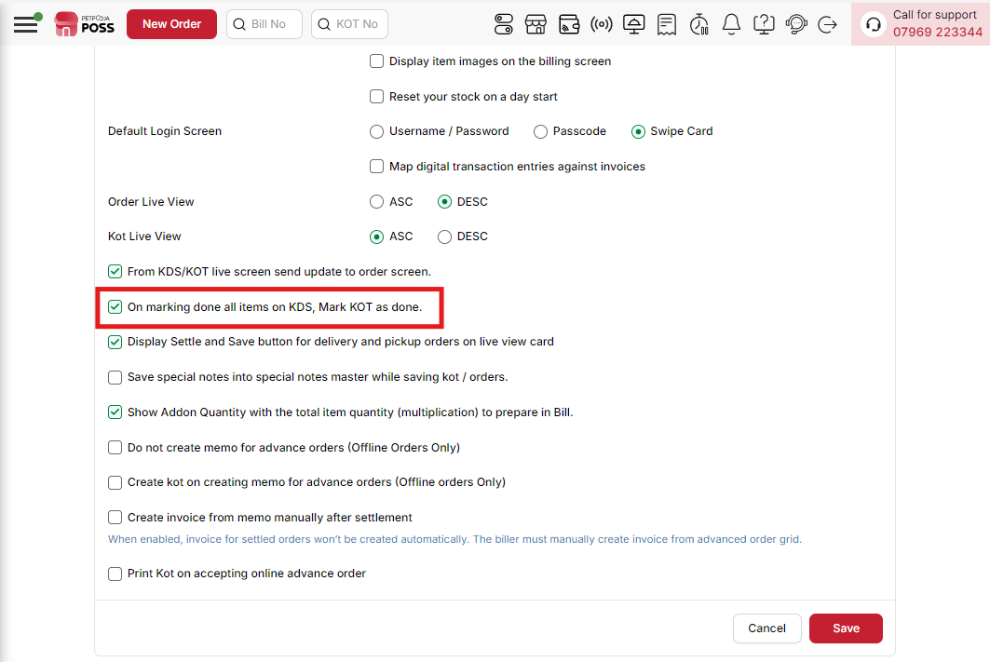
{Image Name: On Marking Done All Items on KDS and Mark KOT as Done,
Description: The red box highlights the option that automatically marks the KOT as completed once all items are marked done in the Kitchen Display System (KDS). This helps streamline the workflow and ensures accurate order completion status.}
(Restaurant Configuration) Display Settle and Save button for delivery and pickup orders on live view card : Enables settlement and saving options for better order management.
- Check: If this box is checked, the Settle and Save buttons will appear on the live view card for delivery and pickup orders. This allows staff to quickly settle payments and save orders directly from the live view screen.
- Uncheck: If this box is unchecked, the Settle and Save buttons will not appear, and staff must go to the billing screen to perform these actions.
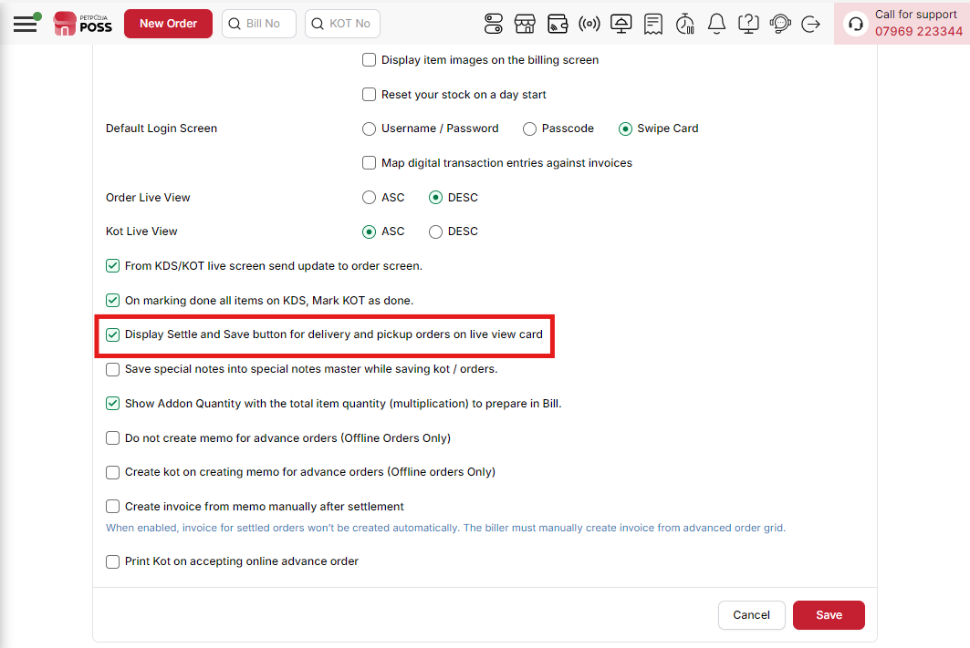
{Image Name: Display Settle and Save Button for Delivery and Pickup Orders on Live View Card,
Description: The red box highlights the option that shows the Settle and Save buttons on the live view card.}
(Restaurant Configuration) Save special notes into special notes master while saving kot / orders. : Stores special instructions while saving KOTs or orders.
- Check: If this box is checked, any special notes or instructions entered while saving KOTs or orders will be saved into the special notes master. This allows staff to reuse these notes easily for future orders.
- Uncheck: If this box is unchecked, special notes will not be saved into the master, and staff will need to enter them manually every time.
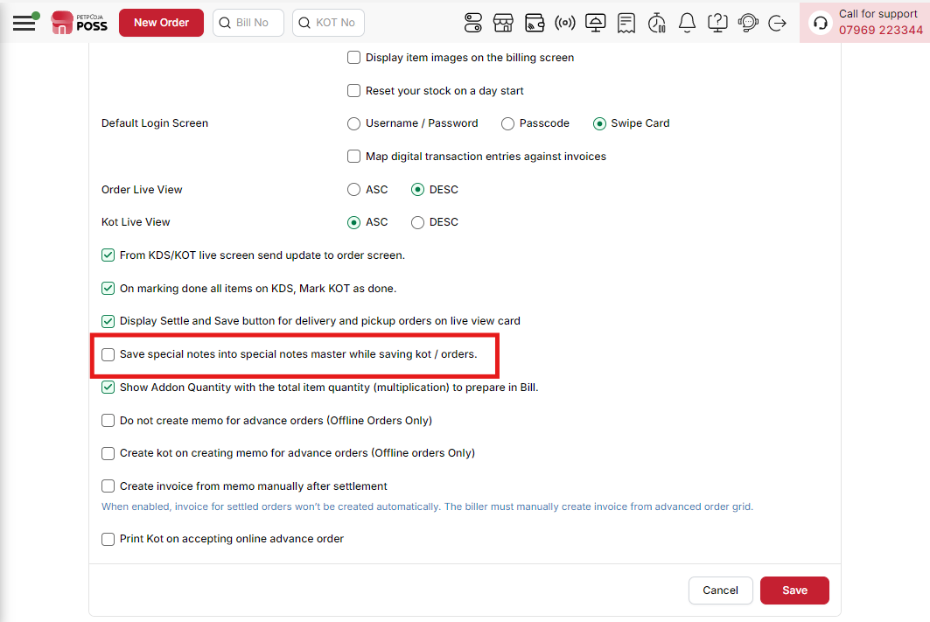
{Image Name: Save Special Notes into Special Notes Master while Saving KOT/Orders,
Description: The red box highlights the option that allows saving special notes entered during KOT or order creation into the Special Notes Master.}
(Restaurant Configuration) Show Addon Quantity with the total item quantity (multiplication) to prepare in Bill. : Displays add-on quantities multiplied with item quantities for billing clarity.
- Check: If this box is checked, the system will multiply the addon quantity by the item quantity and display the total in the bill. This ensures accurate billing and preparation.
- Uncheck: If this box is unchecked, addon quantities will not be multiplied by the item quantity, which may cause confusion during billing or preparation.
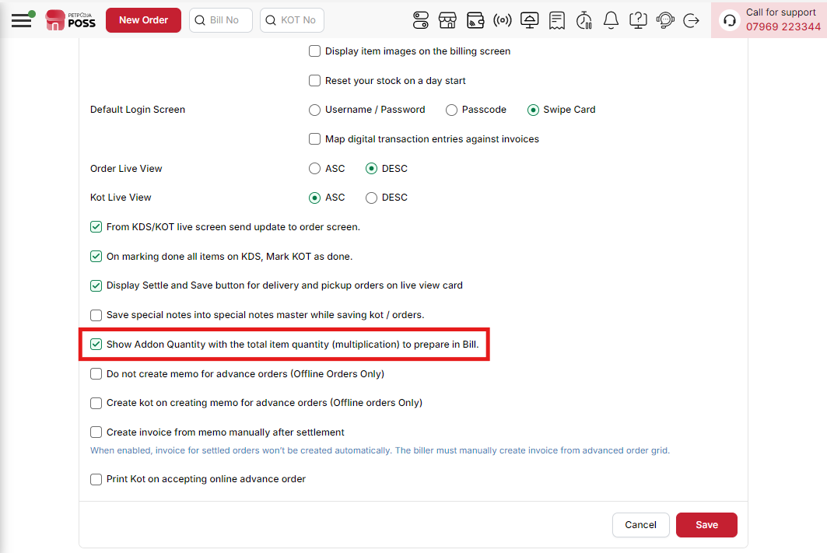
{Image Name: Show Addon Quantity with the Total Item Quantity (Multiplication) to Prepare in Bill,
Description: The red box highlights the setting that displays addon quantities combined with the total item quantity in billing.}
(Restaurant Configuration) Do not create memo for advance orders (Offline Orders Only):
- Check: If this box is checked, the system will not create a memo automatically for offline advance orders. Staff must manually create a memo if needed.
- Uncheck: If this box is unchecked, the system will automatically generate a memo whenever an offline advance order is created.
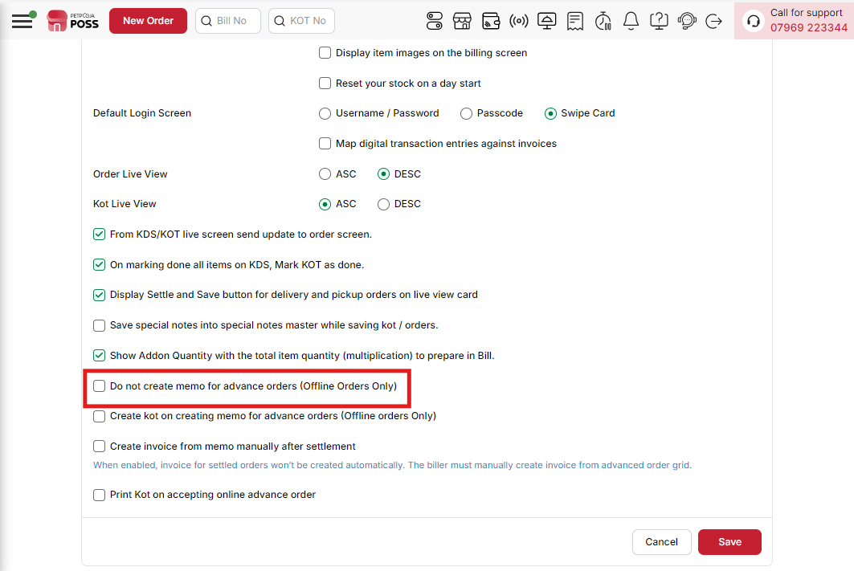
{Image Name: Do Not Create Memo for Advance Orders (Offline Orders Only),
Description: The red box highlights the option to disable memo creation for advance offline orders. Enabling this setting ensures that no additional memos are generated, keeping the order process simple and avoiding duplicate entries.}
(Restaurant Configuration) Create KOT on Creating Memo for Advance Orders (Offline Orders Only) : Automatically generates a Kitchen Order Ticket (KOT) when a memo is created for offline advance orders.
- Check: If this option is checked, whenever you create a memo for an offline advance order, the system will automatically generate a Kitchen Order Ticket (KOT). This helps the kitchen start preparing items without waiting for further action.
- Uncheck: If this option is unchecked, creating a memo for an offline advance order will not generate a KOT automatically. In this case, the KOT must be created manually when needed.
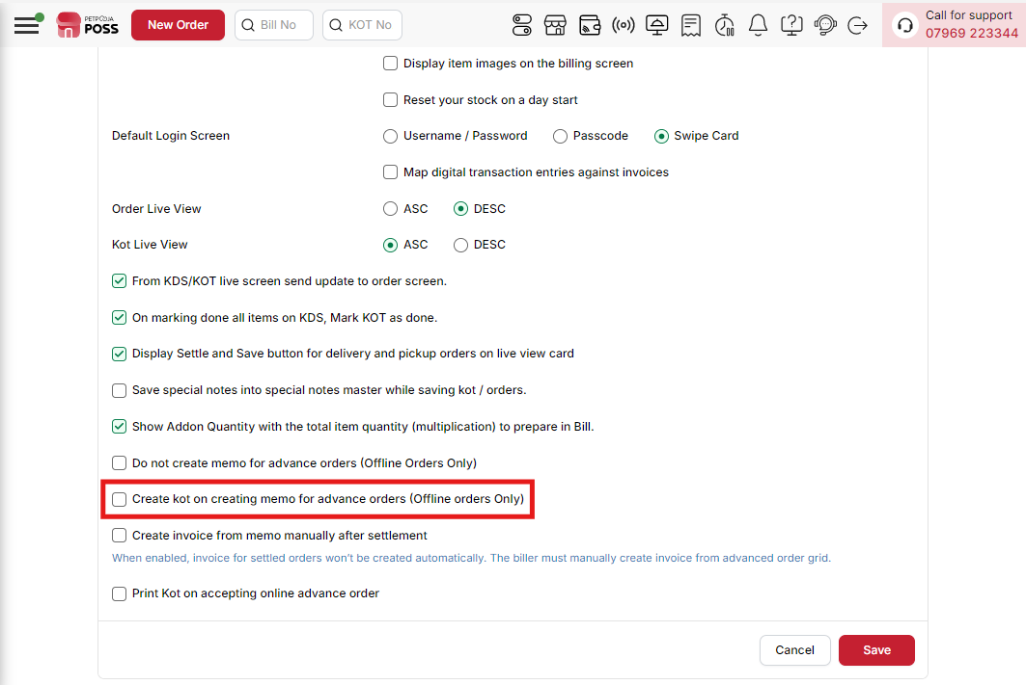
{Image Name: Create KOT on Creating Memo for Advance Orders (Offline Orders Only),
Description: The highlighted option allows automatic KOT generation whenever a memo is created for offline advance orders, ensuring the kitchen receives order details instantly.}

(Restaurant Configuration) Create Invoice from Memo Manually After Settlement (Checkbox) :
- Check: If this box is checked, the system will allow you to create the final invoice manually only after the memo has been settled. This gives you control to decide when to generate the invoice.
- Uncheck: If this box is unchecked, the invoice may be created automatically after settlement, without waiting for manual confirmation.
- Note : When enabled, invoice for settled orders won't be created automatically. The biller must manually create invoices from the advanced order grid.
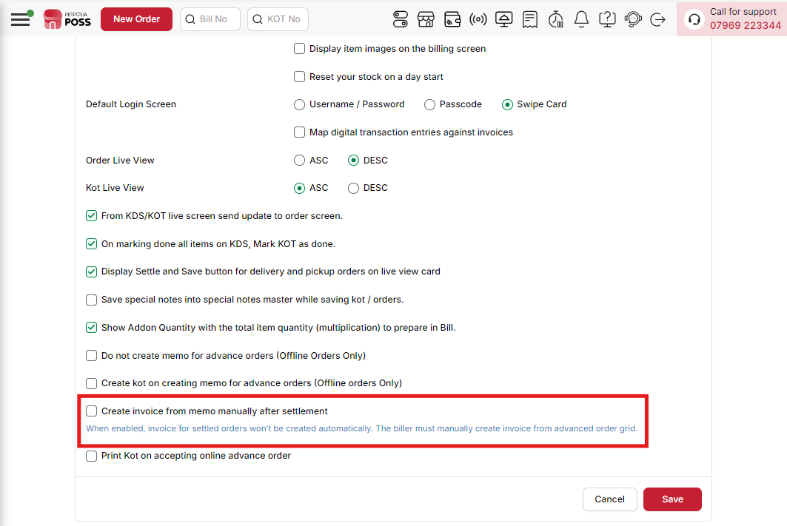
{Image Name: Create Invoice from Memo Manually after Settlement,
Description: The highlighted option requires invoices to be created manually from memos after settlement. Automatic invoice generation is disabled, giving the biller full control.}
(Restaurant Configuration) Print Kot on accepting online advance order :
- Check: If this option is checked, a Kitchen Order Ticket (KOT) will be printed automatically as soon as you accept an online advance order. This ensures the kitchen gets order details immediately for preparation.
- Uncheck: If this option is unchecked, accepting an online advance order will not print a KOT automatically. You would need to print the KOT manually when required.
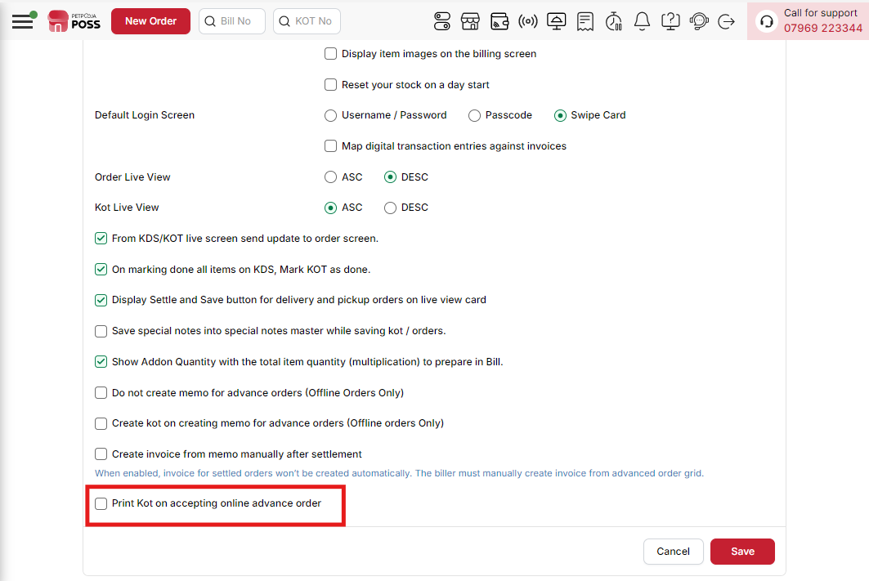
{Image Name: Print KOT on Accepting Online Advance Order,
Description: The highlighted option enables automatic printing of a Kitchen Order Ticket (KOT) whenever an online advance order is accepted, ensuring smooth kitchen processing.}

(Restaurant Configuration) Save & Cancel Options :
- Save – Confirms and applies the selected settings.
- Cancel – Discards any changes and retains previous settings.

